

**FPT ACADEMY INTERNATIONAL**

**FPT – APTECH COMPUTER EDUCATION**

**USER GUIDE**

|  |  |  |  |
| --- | --- | --- | --- |
| **Center Name** | | ACE-HCMC-2-FPT  Address: 590 Cach Mang Thang Tam, District 3, Ho Chi Minh City | |
| **Instructor** | | Mr. Nguyen Van Binh & Mr. Ngo Phuoc Nguyen | |
| **Class** | | T1.2005.E3 | |
| **Group** | | 1 | |
| **Group members** | | **Name** | **Student ID** |
| Hoang Huu Nghia | Student1268270 |
| Nguyen Thien Quan | Student1267396 |
| Vu Ba Thai An | Student1267392 |
| **Duration** | **Start date** | 1st Aug 2020 | |
| **End date** | 1st Sep 2020 | |

**Homepage**

***Homepage includes:***

*(Snow flew – Meals Navigation - Awards – Gallery – Recipe – Catering – About team – Contact – Bottom Navigation) sections.*

**Snow flew sections:**

This section is simple and beautiful for users. It has snow flew and name “Vinegar Food Restaurant”, this will makes users interested.

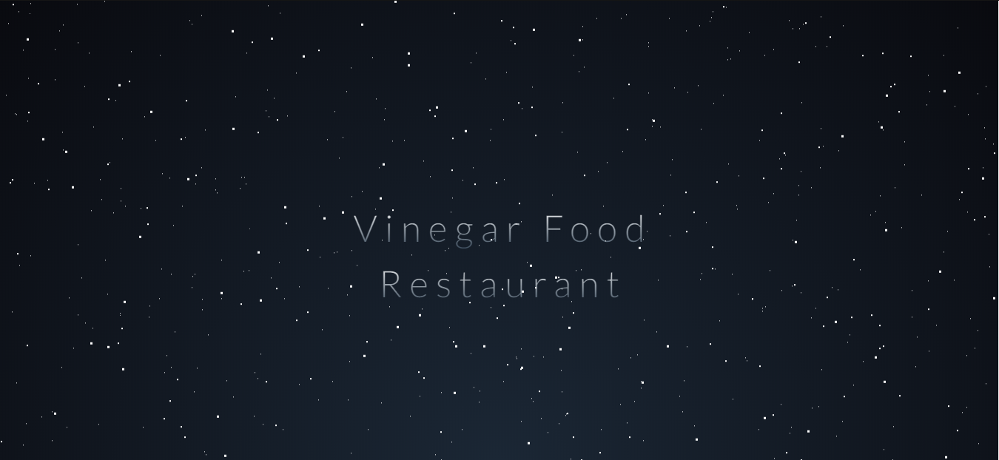

Next when scroll the page shows fixed navigation bottom and Meals navigation.

**Meals Navigation**

When you click on Regular, it tranfers to regular-meals page, also for Lunch, Snacks, Dessert, Beverages is clicked, will tranfers to the corresponding page

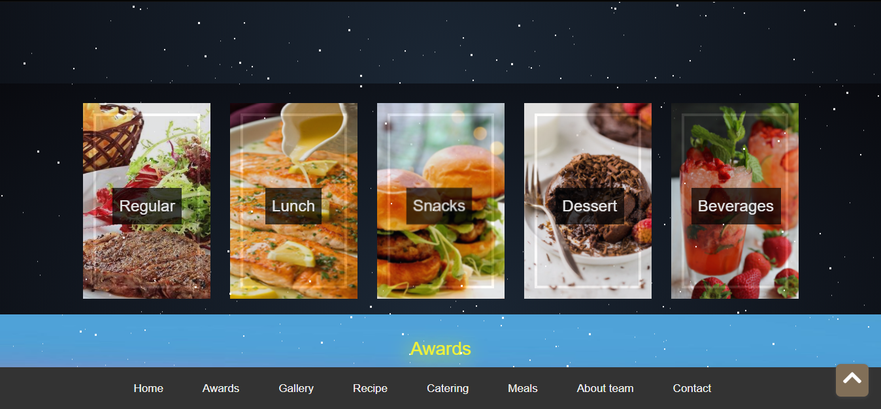

**Fixed Bottom Navigation**

When users click links in fixed bottom navigation, example:

* Home: The Homepage will reset
* Awards: Transfer to the Awards section in this Homepage
* Gallery: Transfer to the Gallery section in this Homepage
* Recipe: Transfer to the Recipe section in this Homepage
* Catering: Transfer to the Catering section in this Homepage
* Meals : Transfer to the Meals navigation section in this Homepage
* About team: Transfer to the About team section in this Homepage
* Contact: Transfer to the footer section in this Homepage
* Button to top: Transfer to the top in this Homepage

**Awards section**

This section shows highlights information of Vinegar Food Restaurant

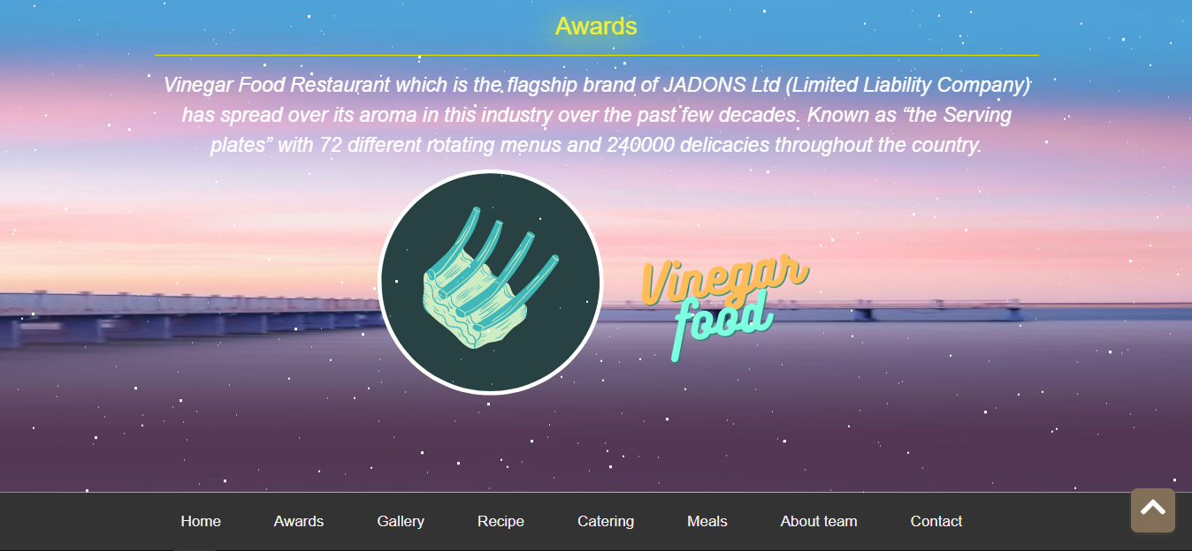

**Gallery section**

A lot of food pictures showed when scroll. You can sort food pictures follow beef, pork, seafood, salad

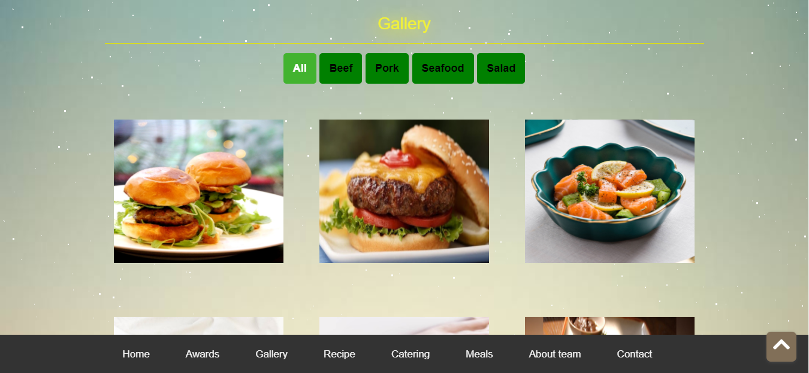

**Recipe section**

This section show recipe of food when user clicks picture

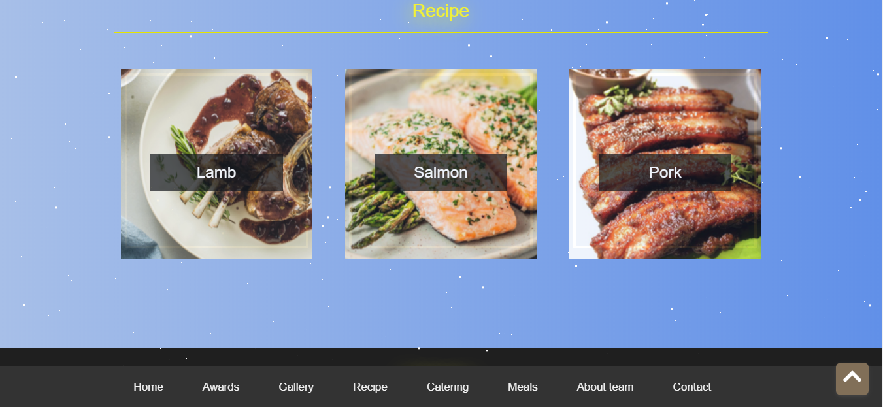

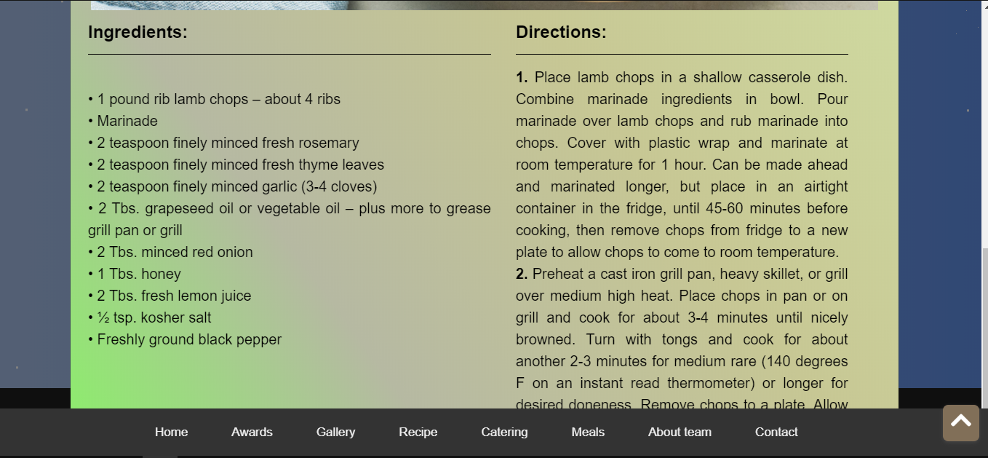

**Catering section**

User can book inside or outside catering when click “Book Here” button. A pop up is appeared, it includes a slider (inside outside catering picture) and 2 button (Booking – Close).

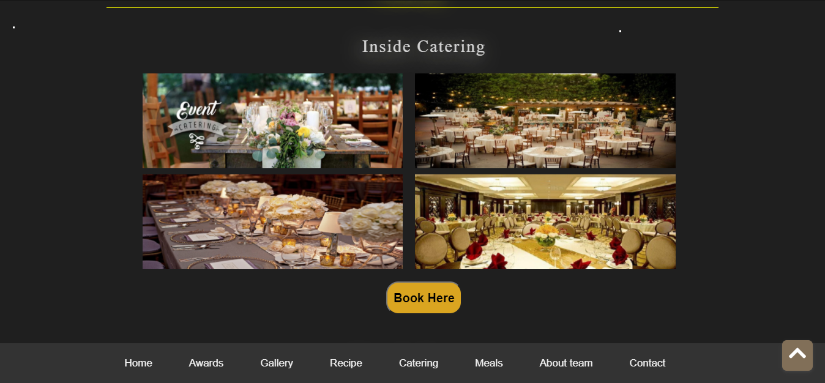

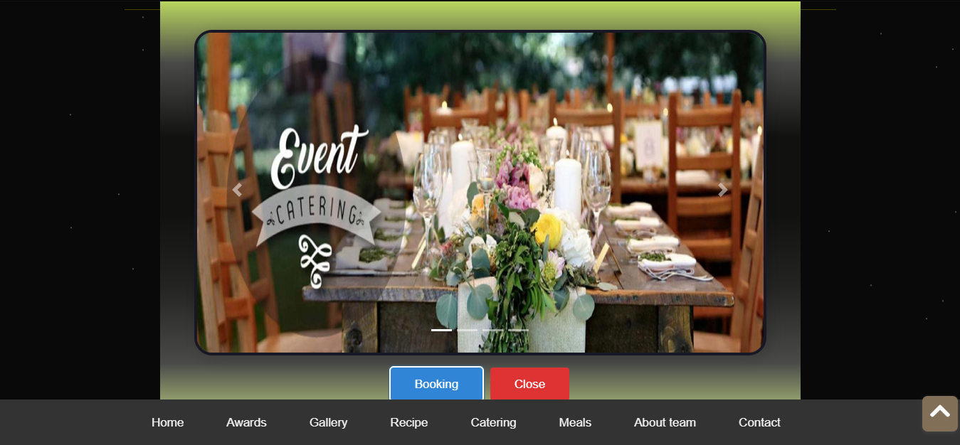

When click booking button/ blue button, a pop up booking shows. Then if users enter correct name and phone the success notification appears.

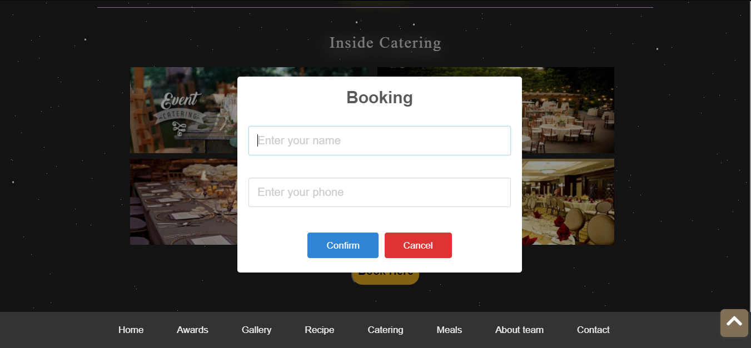

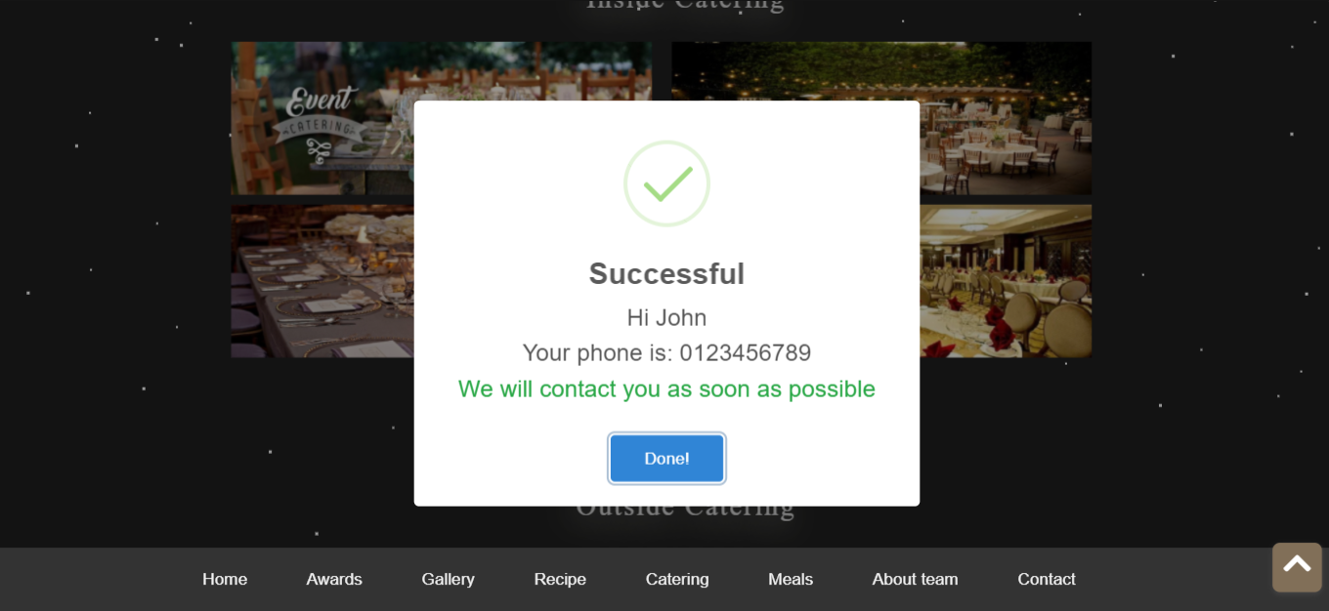

**About team**

This sections show the picture of members development team

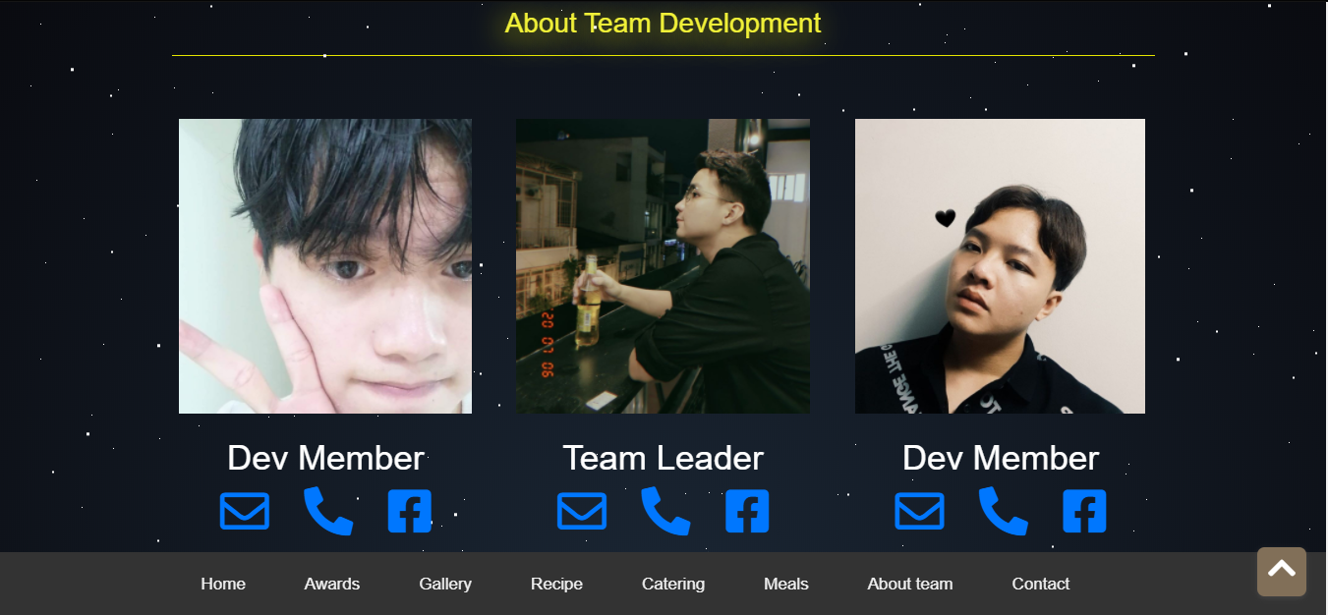

**Contact**

This section includes address phone email and feed back. Also Google API of development team

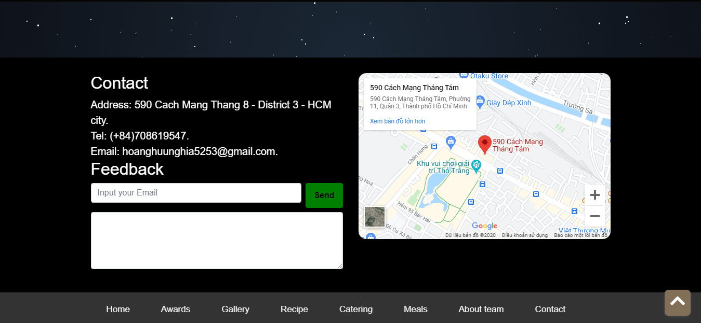

**Responsive bottom navigation**

When width of screen is less than or equal 991px, the fixed bottom navigation transforms as shown below.

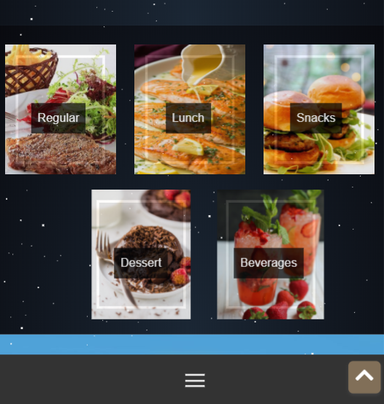

When click that bottom navigation, the links will show. Which links is clicked will transfer to that section

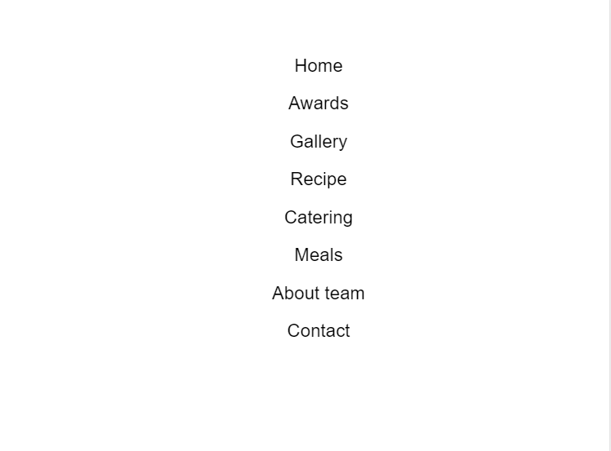

**5 Meals pages**

**Regular – Lunch – Snacks – Dessert – Beverages**

**Similarity between pages**

Every page has the same top navigation, same Meals navigation and same fixed bottom navigation.

**Top navigation**

When users lick links in top navigation :

* Home: Transfer to the Homepage
* Contact: Transfer to the footer section in this page
* Discovery includes 4 links : Awards – Gallery – Recipe – Catering
  + Awards: Transfer to the Awards section in Homepage
  + Gallery: Transfer to the Gallery section in Homepage
  + Recipe: Transfer to the Recipe section in Homepage
  + Catering: Transfer to the Catering section in Homepage
* About team: Transfer to the About team section in Homepage

**Meals Navigation**

When users click on Regular, it tranfers to regular-meals page, also for Lunch, Snacks, Dessert, Beverages is clicked, will tranfers to the corresponding page

**Fixed bottom navigation**

Fixed bottom navigation will appear when scroll. Users lick links in this :

* Home: Transfer to the Homepage
* Awards: Transfer to the Awards section in Homepage
* Gallery: Transfer to the Gallery section in Homepage
* Recipe: Transfer to the Recipe section in Homepage
* Catering: Transfer to the Catering section in Homepage
* Meals: Transfer to the Meals navigation in this page
* About team: Transfer to the About team section in Homepage
* Contact: Transfer to the footer section in this page

**Responsive bottom navigation**

When width of screen is less than or equal 991px, the fixed bottom navigation transforms as shown below.

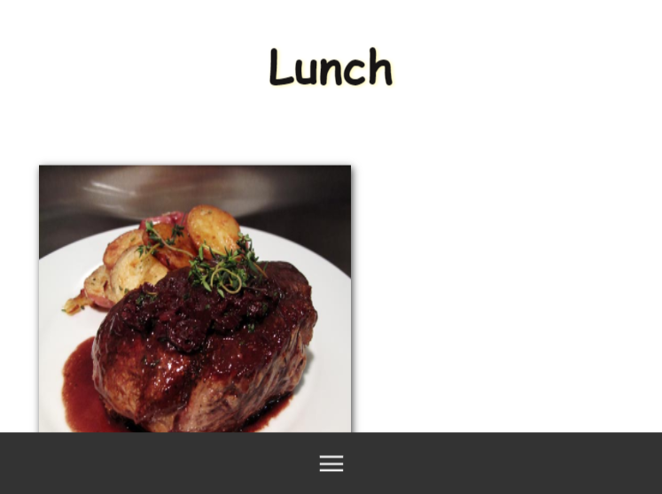

When click that bottom navigation, the links will show. Which links is clicked will transfer to the section as mentioned above. If “Return this page” link is clicked, this page will reset

